**United States Department of Agriculture**

Food and Nutrition Service

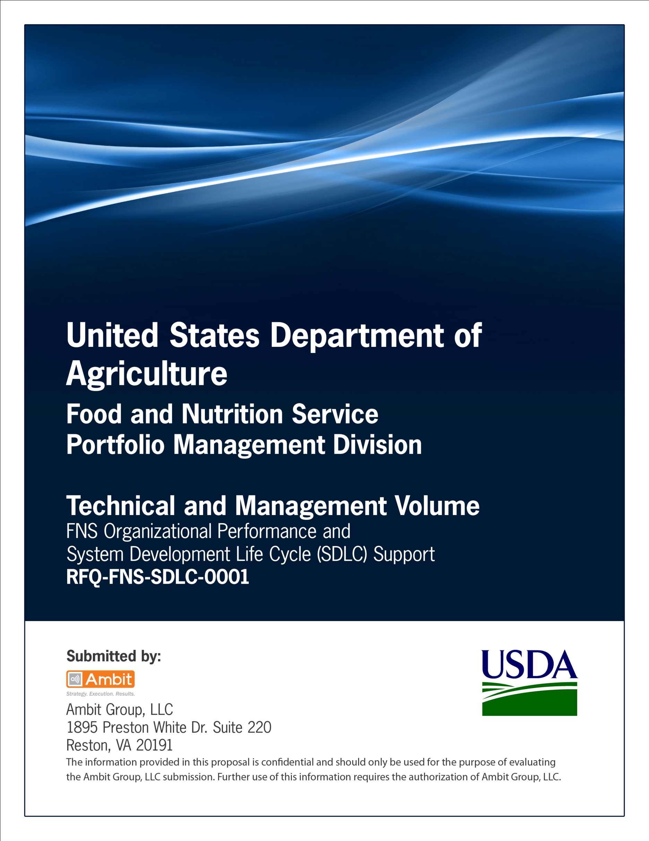

**FNS Office of Information Technology**

**Portfolio Management Division (PMD)**

**FNS Test Results Template**

**for**

**[Project or System Name]**

**Version 1.1**

September 09, 2013

**Revision History**

|  |  |  |  |
| --- | --- | --- | --- |
| **Version** | **Date** | **Author** | **Change Description** |
| 1.0 | 03-18-2013 | IT Governance Branch (ITGB) | Created the document. |
| 1.1 | 09-09-2013 | IT Governance Branch (ITGB) | Re-formatted the document. |
| 1.2 |  |  |  |
| 1.3 |  |  |  |

**Contact Information**

|  |  |
| --- | --- |
| **Area of Concern** | **Contact Person** |
| IT Governance Lead | Kevin Russ |
| SDLC Coordinator | Syed Jaffery |
| ITIRB Coordinator | Sunny Dilawari |
| Portfolio Management Division Director, Chief Portfolio Officer | Jacqueline Butler |
| Program Management Branch Chief | Allison Willcox |

Contents

Glossary 4

1. General Information 5

1.1. Purpose of the Report 5

1.2. Scope of Test Results 5

1.3. System Overview 5

2. Test Summary Report 6

3. Defect Report 6

4. Defect Log 7

Appendix A: References 9

Approvals/Signatures 10

# Glossary

| **Acronym** | **Description** |
| --- | --- |
|  |  |
|  |  |
|  |  |
|  |  |
|  |  |
|  |  |
|  |  |
|  |  |

# General Information

## Purpose of the Report

Describe the purpose of the Test Results and Evaluation Report.

## Scope of Test Results

Describe the scope of the Test Results and Evaluation Report as it relates to the project.

## System Overview

**System Description**

Describe the system in narrative form using non-technical terms.

**Name of System**

Identify the system by its official Title. Also indicate acronym or short name if applicable.

**Sponsor Organization**

Enter the name of the organization that initiated and is champion of this effort.

# Test Summary Report

| **Date of Test** | **Test Case ID** | **Requirement ID** | **Case Summary** | **PASS/FAIL** |
| --- | --- | --- | --- | --- |
| Provide date on which testing is performed in  MM/DD/YYYY format. | Provide Test case ID. | Provide requirement number. | Provide Test Case summary. | Indicate whether the test case passed or failed. |
|  |  |  |  |  |
|  |  |  |  |  |

# Defect Report

Prepare defect report for each defect identified during testing.

**Testing Defect/Problem Report**

|  |  |
| --- | --- |
| **Defect ID** | Insert unique ID for the error. |
|  |  |
| **Defect Title** | Insert a Unique Title for the Issue or Problem including the test case title and step. |
|  |  |
| **Testing Environment** | State the environment in which testing is performed.  For example, IE7, Safari ,etc. |
|  |  |
| **Iteration & Page** | Insert Iteration number. |
|  |  |
| **Priority** | Insert priority of the issue.  High  Medium  Low |
|  |  |
| **Defect Description** | Insert a Description of the Issue or problem encountered. Provide as much information as possible (Page, Keystrokes, Previous Actions, Name of User, Content Issue or Error Message. Print Screens when possible). |
|  |  |
| **Requirement** | Insert the requirements that are being affected. |
|  |  |
| **Attachments** | Are there attachments that will be sent with this issue/Problem Report? If yes, provide the list of attachments. |
|  |  |
| **Comments** | Provide any additional information that would be helpful. |

# Defect Log

| **Defect Identification** | | **Test Results** | | | **Defect Resolution** | | | **Approval** | | |
| --- | --- | --- | --- | --- | --- | --- | --- | --- | --- | --- |
| **Defect ID** | **Status of defect** | **Test Case ID** | **Tester** | **Date** | **Application Developer** | **Resolution Description/Action Plan** | **Resolved Date** | **Re-Tester** | **Re-Test Date** | **Approved Date** |
| Insert defect number. | Select status of the defect:  Opened  Assigned  Resolved  Closed | Insert Test Case Number. | Insert the name of the tester. | MM/DD/YYYY | Insert the name of the developer. | Provide defect resolution plan or the action plan. | Enter defect resolution date in MM/DD/YYYY format. | Insert the name of the re-tester. | Enter Re-test date in MM/DD/YYYY format. | Enter the date on which the defects are marked as resolved. |
|  |  |  |  |  |  |  |  |  |  |  |
|  |  |  |  |  |  |  |  |  |  |  |

# Appendix A: References

Insert the name, version number, description, and physical location of any documents referenced in this document. Add rows to the table as necessary.

The following table summarizes the documents referenced in this document.

|  |  |  |
| --- | --- | --- |
| **Document Name** | **Description** | **Location** |
| Document Name and Version Number | Document description | URL or Network path where document is located |
|  |  |  |
|  |  |  |

# Approvals/Signatures

The undersigned acknowledge that they have reviewed the [name of document] document and agree with the information presented within this document. Changes to this document will be coordinated with, and approved by, the undersigned, or their designated representatives.

|  |  |  |  |
| --- | --- | --- | --- |
| Signature: |  | Date: |  |
| Print Name: |  |  |  |
| Title: |  |  |  |
| Role: | [Project or System Name] Project Manager |  |  |
|  |  |  |  |
| Signature: |  | Date: |  |
| Print Name: |  |  |  |
| Title: |  |  |  |
| Role: | [Project or System Name] Business Owner |  |  |
|  |  |  |  |
| Signature: |  | Date: |  |
| Print Name: |  |  |  |
| Title: |  |  |  |
| Role: | Organization’s Approving Authority |  |  |